

3109 2240 1670

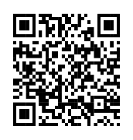

[This Photo](https://www.pngall.com/qr-code-png/download/28384) by Unknown Author is licensed under [CC BY-NC](https://creativecommons.org/licenses/by-nc/3.0/)

Sonam

Hari Shankar

26/10/2005

female

